**A Feasibility Study: Application Of Brain-Computer Interface In Augmentative And Alternative Communication For Non-Speaking Autistic Population**

**Background**

One of the important diagnostic criterion for autism is communication problems 1. Around 25% to 35% of the autistic population are not able to engage in effective spoken communication 2–4. However, “Non-Speaking doesn't mean Non-Thinking,” as mentioned in a poem by a non-speaking person 5. All people have a basic human right to have the resources and supports necessary to communicate their desires, thoughts, & feelings 6. Autistic individuals typically cannot effectively communicate their needs and desires. This can increase their feeling isolated and trigger a variety of emotional problems (e.g., depression) and self-injurious behaviors 7, especially in the non-speaking autistic population 8,9.

There are a variety of approaches (such as Didactic and naturalistic ABA, Pivot Response Treatment, Discrete Trial Training10) that benefit in early childhood to elicit their speech11. However, evidence indicates the difficulty of teaching verbal communication to children after the age of five 12–15. Besides, there are few studies for teaching directly expressive verbal communication to the non-speaking autistic population based on a recent review, though there is a substantial literature on teaching pre-verbal skills (e.g., joint attention, imitation) 12.

In this regard, technology-based Augmented and Alternative Communication (AAC) can be a better strategy for the non-speaking autistic population. AAC benefits the non-speaking autistic population to communicate their needs, thoughts, and desires16–18. A meta-analysis comparing different types of AAC applications (e.g., Picture Exchange [PE], Picture Exchange Communication Systems [PECS], Speech Generating Devices (SGD)), reported thatbBoth SGD and PECS are rated as effective in helping autistic people to communicate basic needs, wants and desires 18. It also reported that many in the non-speaking autistic population prefer using technology-based AAC for communicating18. Tech-based AAC compensates for some difficulties in speaking that older children and adolescents experience16–18 although the use of AAC is “severely understudied” for autistic adolescents and adults19–21, suggesting a real need for developing high-tech AAC considering each autistic person’s needs19. AACs have been less effective for older children and adults compared to preschoolers (5 and younger)22,23. AAC should be easy to use, with low cognitive demand, and address different needs of autistic adolescents 19,21. Currently, AAC applications, however, are not equitably accessible in terms of availability in rural areas, affordability for people with diverse socioeconomic status, and learnability24–26. To use of AAC devices effectively requires training for autistic individuals and extensive theoretical and practical experiences for teachers 11,24,26.

There are inherent limitations in the use of AAC applications for those who have the most significant learning needs, multiple disabilities, and/or motor skills problems 17,18,27,28 as well as those who have the least functional speech 22. Considering the potential of AAC, we aim to expand its modalities for the autistic population by adding brain-interface technology (BCI). BCI can translate brain signals into identifiable words, or/and audiovisual output. The AAC-BCI has been suggested as a beneficial approach for those with significant or multiple disabilities such as Rett syndrome 28 as it has short training times and a simple control task. Further, by direct translation of the brain signals to audio/visual output (or in other words—by direct, natural, neural control of assistive technologies 29), the limitations of traditional AAC devices such as the misattribution of motor movement of participants 30, can be resolved 29.

There has been growing interest in using electroencephalogram (EEG)- based BCI for a variety of conditions, (e.g., autism, aging, and physical disabilities) 31 and a variety of outcomes including rehabilitation (e.g., therapies to regain physical abilities), diagnosis (e.g., coma), recreation (e.g., gaming, art), assistive technology (e.g., communication, mobility) 32. Researchers 33 have found that EEG-based BCI with an accurate algorithm using machine learning (ML) could be influential in leading us to understand and help autistic people develop the capacity to effectively communicate their thoughts, feelings, and ideas. Further, BCI is easy to use and does not need training or using motor skills on part of the participants 25. The evidence indicates using a steady-state visually evoked potentials (SSVEP) paradigm in BCI can contribute to efficient, accurate communication 34. SSVEP can be applied to a variety of populations and conducted in a short time, without needing an overt response, with a high signal-to-noise ratio (SNR) and high information transfer rate (ITR) 34,35.

Based on a brief literature review (from 2015 to 2022), BCI studies in the autism field can be classified into two main categories – for identification and training purposes. For example, BCI can be used to identify signal patterns related to sound/music preferences 36 and the music consistent with autistic children’s moods for therapy purposes 37. Further, the signal patterns related to mental stress 38,39, interest level in a task, and mental workload in autistic children can be detected using BCI 40–43. Social joint attention of autistic children also can be detectable using the BCI technique 33. Among autistic children, training-purposed BCIs have been shown to improve attention using a BCI-based video game 44, social skills using neurofeedback training 45, social joint attention 46–50, and learning to interpret emotional facial expressions and social skills 51 and learning to drive for autistic adolescents 41.

Current studies indicate that using BCI can be useful and feasible in the autism population to improve social skills and teach specific tasks. However, there is no evidence of using BCI to expand AAC or improve communication for autistic people 52. There is a variety of AAC-BCI used with other populations 25,53–59 and established literature on AAC for those with cognitive and literacy problems58 that could be enlightening for our project by adapting their principles and knowledge 58 for us with the autistic population.

An EEG-based BCI is popular to use because it is a non-invasive, safe, and more affordable technique compared to other devices and can facilitate accurate communication 29. *We aim to explore the use of an EEG-based BCI in AAC (12 pictures in this study) for the Non-Speaking Autistic population.* We will study the feasibility of BCI+AAC in autistic individuals who already use AAC successfully because they will not have difficulty with the motor responses and we can explore their comprehension across different modalities. Further, we can compare the results of using BCI with pictorial-AAC and AAC without BCI conditions.  If the results of this project are promising, the possibility of BCI-AAC will be considered for those with significant and multiple disabilities (e.g., autism with significant intellectual disabilities, neurodevelopmental disabilities, such as Rett syndrome).

**Aim**

The proposed study aims to explore the application of BCI-AAC with autistic youth and young adults. Brain signal patterns will be detected using an SSVEP-based BCI in response to visual stimuli (12 pictures) in the non-speaking autistic population. Recognized brain signal patterns from participants will subsequently be translated into audio output presented via a phone app or computer.

**Method**

*Participants*. We will recruit participants (N= 15, age = 12 -18) from autism communities and organizations in MN. They may speak minimally or not be able to speak. For minimally speaking participants, word counts will be assessed based on a guideline to define the level of speech 12. Inclusion criteria: participants should have a formal diagnosis of either autism or neurodevelopmental disability. Those with secondary conditions of mild intellectual disabilities (ID) as well as those without ID will be included. Participants should already have demonstrated an ability to use AAC as well as have normal vision or corrected normal vision (not less than 20/100 on a Snellen test). Photosensitivity assessment will be checked before enrolment in the study with visual light sensitivity questionnaire-8 (VLSQ-8). Exclusion criteria: participants who do not have the mentioned formal diagnoses, those with epilepsy history, those who have metallic cranial implants, and those with moderate or most significant ID will be excluded. Before starting recruitment, the IRB application will be submitted and once it is confirmed, the recruitment will be started. The consent (parent) and assent (youth with ASD) letters will be provided for those who declare their interest in the study voluntarily.

*Measures. The Peabody Picture Vocabulary Test, 5th Edition (PPVT-5)*60,61. This standardized norm-referenced instrument measures receptive language. Further, before each conduction, the comprehension of participants, or receptive attention, from each experiment picture will be checked by asking them to point out each picture by telling the name of the picture. The number of distinct words for minimally-speaking participants will be reported, which was recommended for a clear language phenotype of participants12. *Social Communication Questionnaire (SCQ)*62, a parent questionnaire, will be administered for autism scores and has an excellent concurrent validity.  *Early Reading Screening Instrument (ERSI)* 63 will assess knowledge of letters, the concept of words, and word recognition. This test gives information regarding participants’ degree of literacy. Overall, we will be able to have a clear phenotype of participants regarding the current levels of reading, receptive language and autism scores.

*Study Protocol*. *Task design and BCI modality:* A total of 12 pictures (i.e., AAC) will be selected for the task. In each trial, 4 pictures will randomly be presented on an LCD monitor in front of the subject and 4 LEDs placed in the top left (1), top right (2), down left (3), and down right (4), of the monitor. LEDs flicker with 8, 10, 12, and 15 Hz respectively. Subjects will be requested to select the output command (i.e., one of 4 pictures on the monitor) by paying attention to a sound that defines the number of the picture along with a visual cue (i.e., an arrow pointing at the picture). Each session will include 120 trials and each picture will be presented 10 times. Each trial time is equal to 7 seconds including 5 seconds picture presentation followed by a 2-second rest black/white screen (the total duration of each session will be 14 minutes). Overall, 3 sessions will be presented by inserting about a 5-minute break between sessions. The schematic task design and presentation are shown in Figure 1.

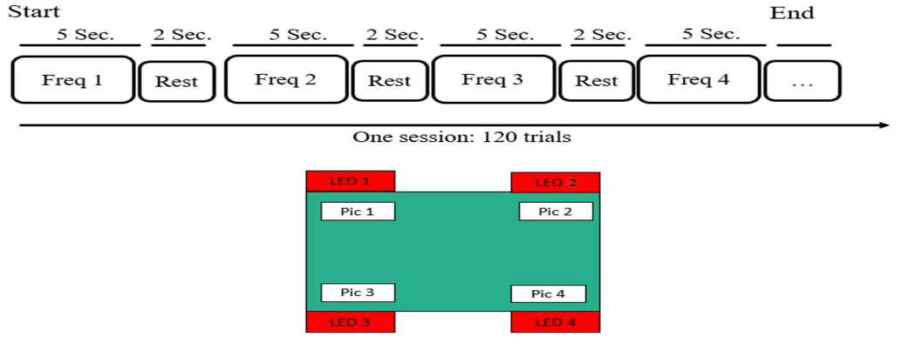

Figure 1: Schematic presentation of task.

*Data acquisition*: Eight channels of EEG signals will be acquired using a 10-20 standard system. Electrodes will be placed in occipital and parietal areas. The right ear and Fpz are dedicated to reference and ground electrodes respectively. Online notch (50 Hz) and bandpass filters (2-100 Hz) will be used. The frequency sampling frequency in this study is 512 Hz. The location of EEG electrodes is depicted in Figure 2. Synchronization pulses/trigger signals will be recorded simultaneously with EEG signals.

|  |  |
| --- | --- |
| Frontiers | How Many People Could Use an SSVEP BCI? | Neuroscience |  |
| Figure 2: The location of EEG electrodes. | Figure 3: General block diagram of the experimental setup and data analysis. |

*Data analysis*. Firstly, EEG data will be preprocessed with a baseline correction and offline appropriate bandpass filters. Then the data of each trial will be extracted using triggers/ synchronization pulses. After the preprocessing, extracted signals of each trial will be analyzed with time, frequency, and time-frequency analysis. Informative features for each analysis will be used in the input table of machine learning methods. Machine learning methods (e.g., SVM, Decision tree, etc.) classify the signals and determine the output command. A general block diagram of the experimental setup and data analysis is illustrated in Figure 3. Further, the data from the SCQ, PPVT-5, and ERSI will be reported and analyzed descriptively.

*Performance analysis*. Two well-known criteria will be measured for validation of the analysis. Accuracy (Acc) defines the fraction of corrected trials for all trials (Eq.1). Information transfer rate (ITR).  A general evaluation metric devised for BCI systems determines the amount of information that is conveyed by a system's output. ITR is equal to information transferred in bits per trial, N= number of targets, and P is equal to the classification accuracy. It is calculated by dividing the number of correct command classifications by the total number of classified commands (Eq.2).

|  |  |
| --- | --- |
| (Eq.1) |  |

***Other requirements for application***

*Which MIDB cores will be utilized to facilitate the research? (½ page)*

Considering the interdisciplinary nature of the proposed project, we will collaborate across multiple departments/centers at MIDB as follows. Jessica Simacek, with extensive knowledge in autism and interdisciplinary research areas, the director of “*TeleOutreach Core (TOC)*” core, and Mark Fiecas with the interdisciplinary areas including EEG and time series, the director of “*The Measurement and Human Phenotyping Core (MHPC)*” contribute to this project. TOC and MHPC will facilitate this project by providing the related knowledge and skills on autism, brain science as well as equipment (e.g., EEG), data acquisition (EEG data), and testing rooms (to conduct surveys and experiments).

*Applications should provide a statement of how the work fits the mission of the MIDB (½ page) and confirm whether the study will take place at MIDB.*

The use of BCI requires interdisciplinary cooperation of researchers (with expertise in rehabilitation science, psychology, clinicians, machine learning, and signal processing) to improve its applicability and convenience as well as benefits for clients 37. The proposed project will require the use of MIDB research facilities testing rooms and EEG facilities and assistance. For this reason, MIDB can be an appropriate place where the project can take place. The current project brings experts from different fields to improve life outcomes and quality of life by facilitating communication for autistic youth and young adults.

*Updated CV*

In the next page.

**Maryam Mahmoudi**

ARRT Postdoctoral Associate

University of Minnesota

Institute on Community Integration (ICI)

College of Education and Human Development (CEHD)

Masonic Institute for Developing Brain (MIDB)

2025, East River Parkway,

Minneapolis, MN, 55414

Phone number: 612-624-1144 (o); 612-461-6649 (c)

Email address: [mmahmoud@umn.edu](mailto:mmahmoud@umn.edu)

**EDUCATION**

Allameh Tabataba’i University, Tehran, Iran

Department of Psychology, Ph.D. Psychology and Special Education 2017

Degree awarded with Highest Distinction in recognition of honors dissertation:

"Developing Comprehensive Emotion Regulation Program (CERP) and Evaluating its Effectiveness on

Emotion Regulation, Executive Functions and Social Problem-Solving in Children with LD”

University of Tehran, Tehran, Iran

Department of Psychology and Education of Exceptional Children,

M.A. Psychology and Special Education 2012

Degree awarded with Highest Distinction in recognition of honors thesis:

“Designing an expert system to screen for autism”

University of Isfahan, Esfahan, Iran

Department of Psychology and children with special needs,

B.A. Psychology and Special Education 2009

Degree awarded with Highest Distinction in recognition of honors

**“**Emotional problems and brain lesions in children with stuttering in Shiraz”

**RESEARCH EXPERIENCE**

University of Minnesota, Minneapolis, MN

Institute on Community Integration

ARRT Postdoctoral Associate 2021-present

Literature Review, Analyzing Data, Writing Grant Proposal, Deigning Questionnaires,

Designing Projects, Applying For Grants, Writing Budgets

Norwegian University of Science and Technology (NTNU), Norway

Department of ICT and Science 2019-2020

Social Robot Lab

ERCIM Postdoctoral fellow

Developing Projects, Conduction, IRB, Grant Writing, Presenting Paper Conferences,

Exchange Program, Leaning and Working With Social Robots and Other Technologies

University of Shahid Beheshti, Iran

Department of Psychology and Education 2017-2018

Research Assistant, writing manuscripts, writing books, translation, and statistical analysis

University of Tehran, Iran

School of Electrical and Computer Engineering

Researcher 2011-2019

Collaborating with social robot projects, developing interventions, analyzing data,

behavioral coding for videos, writing manuscripts

University of Tehran, Iran

Faculty of Psychology and Educational Science

Research Assistant 2009-2019

Collaborating with anger management project, social problem solving project,

translating, analyzing data, writing manuscripts, Literature review, book revision

Tarbiat Modares University, Iran

Faculty of education

Research Assistant 2014-2016

Collaborating with Longitudinal project on educational acceleration and radical educational

acceleration, writing manuscripts, literature review

Ministry of Education, Iran

Research Institute for EC

Research Assistant 2013-2015

Collaborating with early identification of children with learning disabilities project and

developing program to identify adaptive problem in children, literature review, organizing material

**PUBLICATIONS**

*Journal Articles (in English)*

Mahmoudi, M., Hameed, A. I. (under review). Attractiveness, acceptability and likeability of socially assistive robots for the elderly: a literature review. International Journal of Social robotics.

Mahmoudi, M., Southam-Gerow, M.A., & Akbari-Zardkhaneh, S. (In review). Emotion Regulation in Children with Learning Disorders: A Preliminary Comparative Study.

Akbari Zardkhaneh, S., Zanganeh, A., Mahdavi, M., Mansour-Kiaee, N., Mahmoudi, M., Jallalat-e-Danesh, M., & Tahmasebi-Garmtani, S. (in review). Development and Psychometric Evaluation of the Nemad Electronic Mental-Health Assessment Devices for Children (NEMAD-C): Parent and Teacher Reports. Social Psychiatry and Psychiatric Epidemiology (SPPE).

Soleiman, Pegah, Hadi Moradi, Maryam Mahmoudi, Mohyeddin Teymouri, and Hamid Reza Pouretemad. (2021). “Teaching Turn-Taking Skills to Children with Autism Using a Parrot-Like Robot.” ArXiv:2101.12273 [Cs], January 28, http://arxiv.org/abs/2101.12273.

Mahmoudi, M., Akbari-Zardkhaneh, S., Zadeh, A. A. B., Ghobari-Bonab, B., Shokoohi-Yekta, M., Moradi, H., & Pouretemad, H. R. (2018). An Autism Screening Expert System: Reliability, Validity and Factorial Structure. Autism-Open Access, 8(3). https://doi.org/10.4172/2165-7890.1000230

Shokoohi-Yekta, M., Rath, J. F., & Mahmoudi, M. (2018). “Thinking Child” Program: Effects on Parenting Styles and Family Problem-Solving Skills, Int J Behav Sci, 6.

Mahmoudi M, Akbari-Zardkhaneh S, Zadeh AAB, Ghobari-Bonab B, Shokoohi-Yekta M, et al. (2018) An Autism Screening Expert System: Reliability, Validity and Factorial Structure. Autism Open Access 8: 230. doi:10.4172/2165- 7890.1000230

Shokoohi-Yekta, M., Alimohammadi Malayeri, S., Akbari Zardkhanhe, S., & Mahmoudi, M. (2015). Effectiveness of an Intervention Program to Improve Parent-Adolescent Relationships. Procedia - Social and Behavioral Sciences, 205, 43 – 47.

Soleimman-Dehkordi, P., Moradi, H. Mahmoudi, M., Pouretemad, HR. (2015). The Design, Development, and Deployment of RoboParrot for Screening Autistic Children. Int J of Soc Robotics. 7:513–522.

Shokoohi-Yekta, M., Mahmoudi, M., Ghobari- Bonab, B., Bagherzadeh, A. A., Moradi, H., Pouretemad, H., Akbari Zardkhaneh, S., & Lotfi, S. (2013). Developing Autism Screening Expert System (ASES). AWERProcedia Information Technology & Computer Science, 04, 1074-1078.

Shokoohi-Yekta, M., Mahmoudi, M., Ghobari- Bonab, B., Akbari Zardkhaneh, S., & Lotfi, S. (2013). Online expert system for screening autism: an item analysis. AWERProcedia Information Technology & Computer Science, 04, 1074-1078.

Soleimman-Dehkordi, P., Salehi, S., Mahmoudi, M., Ghavami, M. Moradi, H. Pouretemad, HR. (2014). RoboParrot: A robotic platform for human robot interaction, case of autistic children. IEEE, Proceeding of the 2nd RSI/ISM International Conference on Robotics and Mechatronic, October 15-17, 2014, Tehran, Iran

Shokoohi-Yekta, M., Mahmoudi, M., Ghobari- Bonab, B., Akbari Zardkhaneh, S., & Lotfi, S. (2013). Designing an expert system to screen for autism: Investigating psychometric properties. AWERProcedia Information Technology & Computer Science, 04, 1074-1078.

Soleimman-Dehkordi, P., Salehi, S., Mahmoudi, M., Teimouri, M., Moradi, H. Pouretemad, HR. (2011). The Use of RoboParrot in the Therapy of Children with Autism Children: In Case of Teaching the Turn-Taking Skills, Springer-Verlag Berlin Heidelberg.

*Journal Articles (in Persian)*

Shokoohi-Yekta, M., Akbari Zardkhaneh, S., & Mahmoudi, M. (In reviewing). Effectiveness of psycho-social training package on anger and aggression in urban bus drivers. Security and Social Order Strategic Studies Journal.

Mahmoudi, M., Borjali, A., Alizadeh, H., Ghobari-Bonab, B., Ekhtiar, H., & Akbari-Zardkhaneeh, S. (In reviewing). Emotion understanding in children with learning disorders and normal children. Journal of Clinical Psychology Andishe va Raftar.

Shokoohi-Yekta, M., Akbari Zardkhaneh, S., Mahmoudi, M., & Dashti, D. (2018). Efficacy of anger management training on hostility and well- being of parents. Knowledge & Research in Applied Psychology, 19. No. 2 (Continuous No. 72)- summer, PP: 44-53.

Shokoohi-Yekta, M., Akbari Zardkhaneh, S., & Mahmoudi, M. (2017). Effectiveness of Anger Management Training based on Cognitive-Behavioral Approach on Parents' Aggression and Mental Health. Psychological Research, 20, 1, 7-22.

Shokoohi-Yekta, M., Akbari Zardkhaneh, S., Mahmoudi, M., & Alavi, S. (2016). Effects of Teaching Advanced Parenting Programs on the Relationship Process in the Family. Quarterly Journal of Child Mental Health, 4(1), 35-46.

Mahmoudi, M., Borjali, A., Alizadeh, H., Ghobari-Bonab, B., Ekhtiar, H., & Akbari-Zardkhaneeh, S. (2016). Emotion regulation in children with learning disorders and normal children. Quarterly Journal of Research in school and virtual learning, 4, 13, 69-84.

Shokoohi-Yekta, M., Akbari Zardkhaneh, S., Parand, A., Mahmoudi, M., & mashrouti, P. (2016). Effect of Teaching Problem Solving to Mothers on Family Processes and Parenting Styles. Quarterly Journal of Child Mental Health, 3, 1, 3-29.

Shokoohi-Yekta, M., Akbari Zardkhaneh, S., & Mahmoudi, M. (2015). Effectiveness of psychosocial skills training on driver's aggression and anger. Journal of Psychological Models and Methods, 6(21), 21-38.

Taziki, T., Mahmoudi, M., Ghobari-Bonab, B., & Ghasem-Zadeh, S. (2015). Longitudinal study: effectiveness of self-monitoring program on reduction of behaviors inattentive behaviors in slow paced students. Quarterly Journal of Slow Paced children, 3 (5), 349-363 [in Persian]

Shokoohi-Yekta, M., Akbari Zardkhaneh, S., & Mahmoudi, M. (2015). Teaching interaction strategies based on problem solving and its effects on parenting style and problem solving in the family. The Quarterly journal of Psychological science, 14, 55, 373-387.

Beh-Pajooh, Ahmad., Mahmoudi, M. (2015). Need assessment for social support in mothers of children with autism. Rooyesh-e-ravanshenasi, 4(11): 3-22.

Akbari-Zardkhaneh, S., & Mahmoudi, M. (2015). The Efficacy of Adolescent Development Training Program to Parent on Parent-Child Relationship and Family Function. Quarterly Journal of Child Psychological Development, Vol. 2, 2, 55-66.

Shokoohi-Yekta, M., Zamani, N., Mahmoudi, M., Pourkarimi, J., & Akbari Zardkhaneh, S. (2014-2015). Efficacy of cognitive-behavioral interventions on anger control of high school students. Scientific-Research Journal of Shahed University, 21(11), 61-70.

Mahmoudi, M., Ghobari Bonab, B., Shokoohi-Yekta, M., Pouretemad, H., Akbari Zardkhane, A. (2014). Preliminary study of psychometric properties of autism screening expert system for children with autism 2-6 years old. Journal of Exceptional Children, 4, 11: 94-110.

Mahmoudi, M., Ghobari Bonab, B., Shokoohi-Yekta, M., Pouretemad, H., Akbari Zardkhane, A. (2014). Preliminary study of expert system development in diagnosis of autism in children aging 2 to 6 years old: adequacy evaluation of items. Journal of Psychology, 18, 1: 94-110.

Khodayari-fard, M., Paknejad, M., Akbari, S., & Mahmoudi, M. (2012). The status of social-political attitude and social adaptation of wounded wars children. Applied Psychological Research, 3(2): 13-24.

Poursharifi, H., Akbari Zardkhaneh, S., Yagubi, H., Peyravi, H., Hassan Abadi, H. R., Hamid Pour, H., Sobhi Gharamaleki, N., & Mahmoudi, M. (2012). Psychometric properties of Iranian Mental Health Scale for students. Applied Psychological Research, 3(3): 61-84.

*Books*

Arjmandnia, A. A. Mahmoudi, M. (2015). Strategies to improve working memory. Tehran: NashreFarhang. (In Persian)

Arjmandnia, A. A., Khanjani, M., & Mahmoudi, M. (2011). Strategies of rising hope in students and youth. Tehran: Office of Cultural Studies and Social Planning Ministry of Science, Research and Technology. (In Persian)

*Conference Articles*

Mahmoudi, M., Hameed, I.A. (2019). Cognitive rehabilitation for the elderly using social robots: a brief review. In Proceedings of ICERI2019, Spain.

Hameed, I.A., Mahmoudi, M. (2019). “ICPS-NAO”: Nurturing thinking children using a social robot. In Proceedings of ICERI2019. Spain.

Shokoohi-Yekta, M., Akbari Zardkhaneh, S., & Mahmoodi, M. (2013). Impact of teaching problem solving program in the family. The 6th International Congress of Child and Adolescent Psychiatry, September, Tabriz-Iran.

Shokoohi-Yekta, M., Akbari Zardkhaneh, S., & Mahmoudi, M. (2012). The impact of cognitive-behavioral intervention on anger management of high school students. Advances in Child and Adolescent Psychiatry. Paper presented at The 5th International Congress of Child and Adolescent Psychiatry. October 8, 2012 – October 11, 2012.

Ghobari Bonab, B., Taziki, T., & Mahmoudi, M. (2012). Effectiveness of self-monitoring training on reduction of attention problems in children with intellectual disabilities and attention deficit hyperactivity disorder. Advances in Child and Adolescent Psychiatry. Paper presented at The 5th International Congress of Child and Adolescent Psychiatry. October 8, 2012 – October 11, 2012.

Mahmoudi, M., Ghobari-Bonab, B., & Shokoohi Yekta, M. (2012). Application of Expert systems in Diagnosis and Rehabilitation of Children with Developmental Disabilities. Advances in Child and Adolescent Psychiatry. Paper presented at The 5th International Congress of Child and Adolescent Psychiatry. October 8, 2012 – October 11, 2012.

Baghezedeh, A. A., Mahmoudi, M., Moradi, H., Pouretemad, H., Ghobari, B., Shokoohi, M. (2012). An Online Expert System for Autism Screening. Advances in Child and Adolescent Psychiatry. Paper presented at The 5th International Congress of Child and Adolescent Psychiatry. October 8–11.

Beh-Pajooh, A., Mahmoudi, M., Ofoghi, H. (2012). Assessing need for social support in parent of children with autism disorder. Advances in Child and Adolescent Psychiatry. Paper presented at The 5th International Congress of Child and Adolescent Psychiatry. October 8–11.

Mahmoudi, M., Ghobari-Bonab, B., & Shokoohi Yekta, M. (2012). Symptoms prevalence in Iranian children with autism. Paper presented at The 3th National Congress of Iranian Psychological Association. February 25-27.

Mahmoudi, M., Afrooz, GH., Dousti, M. Motor therapy and Down syndrome. Paper presented at The 1th National congress of school and child with special needs. October 23-24, 2012.

Mahmoudi, M., Yarmohammadian, A., & Akrami, Nahid. Emotional problems and brain lesions in children with stuttering in Shiraz. Paper presented at The National congress of education and health in pre-school children. May 15, 2012.

**RESEARCH INTERESTS**

Neurodevelopmental Disabilities; Interdisciplinary Research; Socially Assistive Robots, Developmental Psychopathology; Emotion Regulation; Social Problem Solving; Neuroimaging Studies

**CLINICAL EXPERIENCE**

Zafar clinic, Tehran, Iran

Therapist, Evaluator 2015-2019

Cognitive training for children with Neurodevelopmental Disabilities

Testing, Developing intervention plans

Ostad Roozbeh clinic

AssistantTherapist 2014-2015

Developing intervention and measurement plans for children with IDD

Faranak clinic

Therapist 2013-2014

Assistance in Parent Child Mother Goose Program for children with hearing impairments,

Therapy for children with behavioral problems; parenting training

Center for treatment of autistic disorders (CTAD)

Beh-Ara autistic clinic

AssistantTherapist, Intern 2010-2013

Assistance in training and diagnostic interview for children with autism

Higher Institute of Oxin

Educational counselor 2008-2013

Individual Educational Planning, time management, reading strategies,

analyzing educational tests and progresses

Exceptional elementary schools

Alzahra Hospital

Intern 2006-2008

Observing, helping in producing educational material for children with IDD;

visual impairments, hearing impairments, intellectual disabilities; autism

**SERVICE**

University of Tehran

Department of psychology 2010-2012

Executive committee member

Conducting educational workshops in the psychology field

**GRANTS**

University of Minnesota

CEHD JumpStart grant 2021-2022

Role: Co-Principal Investigator & Project Coordinator

Project: “Enhancing physical activity among older adults using Nao, a socially assistive robot (SAR)”

Total amount: $50,000

**HONORS/AWARDS**

Honor for the best poster in The 5th International Congress of Child and Adolescent Psychiatry, 2012

Tehran, Iran

Ranked 1th among more than 13000 participants in nationwide university entrance M.A. exam, 2009

Iran

**SKILLS**

Software: SPSS; NVivo, Qualtrics; WebPlotDigitizer,

Overleaf; Covidence; Ryan; Zotero, basic Git

Languages: Farsi (native), English (fluent)

**COURSES/WORKSHOP ATTENDED**

|  |  |
| --- | --- |
| EPSY 5261 (001) Statistical Methods, Spring course, College of Education and Human Development, University of Minnesota, Spring semester. | 2022 |
| EPSY 5123 (001), Programming Workflows for Psychological Research, Spring course, College of Education and Human Development, University of Minnesota, Spring semester. | 2022 |
| Github For Researchers, Brock University | 2022 |
| Latex with Overleaf, Brock University | 2022 |
| Research Involving Human Subjects (RCR). University of Minnesota. | 2021 |
| Social / Behavioral or Humanist Research Investigators and Key Personnel. University of Minnesota. | 2021 |
| Social / Behavioral or Humanist Research Investigators and Key Personnel - Refresher Course 1 (HRP107), Section: 001. University of Minnesota. | 2021 |
| RCR-Human Subjects (RC4201) Section: 001. University of Minnesota. | 2021 |
| Preventing Sexual Misconduct, Discrimination and Retaliation (PIPSME), Section: 001. University of Minnesota. | 2021 |
| Assessing Capacity to Consent to Research (HRP103), Section: 001. University of Minnesota. | 2021 |
| Python Basics for Data Science with edX! | 2021 |
| Academic Writing Made Easy (on edX) | 2021 |
| Grant Writing and Crowdfunding for Public Libraries, held by University of Michigan (on edX) | 2021 |
| Introduction to Web Scraping - - held by Liberal Arts Technology & Innovation Services (LATIS), College of Liberal Arts, Department of Statistics, University of Minnesota (online) | 2020 |
| Introduction to Web APIs in Python, held by Liberal Arts Technology & Innovation Services (LATIS), College of Liberal Arts, Department of Statistics, University of Minnesota (online) | 2020 |
| Introduction to NVivo, held by Liberal Arts Technology & Innovation Services (LATIS), College of Liberal Arts, Department of Statistics, University of Minnesota (online) | 2020 |
| Introduction to Python for Social Science - held by Liberal Arts Technology & Innovation Services (LATIS), College of Liberal Arts, Department of Statistics, University of Minnesota (online) | 2020 |
| Webinar: ACRP Certification: Why, Who and How Should You Prepare, held by the association of clinical research professionals (online) | 2020 |
| Experimental Design in Qualtrics workshop, held by Liberal Arts Technology & Innovation Services (LATIS), College of Liberal Arts, Department of Statistics, University of Minnesota | 2020 |
| Machine Learning, by Stanford University (online) | 2020 |
| Introduction to R Workshop, held by Liberal Arts Technology & Innovation Services (LATIS), College of Liberal Arts, Department of Statistics, University of Minnesota (online) | 2020 |
| Torrance Tests of Creative Thinking, held by the Ministry of Petroleum. Tehran, Iran. | 2017 |
| Neuroimaging Workshop: functional MRI imaging and data analysis by FSL, presented by Neuro Imaging Analysis Group (NIAG) at Imam Khomeini Hospital. | 2015 |
| "Neuropsychological rehabilitation", presented by Professor Wilson and Dr. Winegardner, at Shefa Neuroscience Research Center | 2015 |
| "Kestenberg Movement Profile", presented by Prof. Kestenberg, at Allameh Tabataba'I University | 2013 |
| "ADHD software for attention", presented by Dr. Nokani, at University of Tehran | 2011 |
| “CBT course”, presented by Dr. Shafi-Fard, at University of Tehran | 2011 |
| "psychology and culture”, The international congress of psychology, religious and culture | 2011 |
| "the forgiveness protocol", presented by Dr. Ghobari-Bonab, in the University of Tehran | 2011 |
| "autism diagnosis and treatment", presented by Mrs. Azizi, in the University of Tehran | 2011 |
| "music therapy and autism spectrum disorder", Shahid Beheshti University | 2009 |

**MEMBERSHIPS/VOLUNTEERING**

Autism Mentorship Program (AMP), Member of Community Advisory Board 2022-present

Minnesota Psychological Association, Member 2020-present

Quarterly Psychology of Exceptional Individuals, Reviewer 2019-2020

Journal of Autism and Developmental Disorders (JADD), Reviewer 2017-2019

“Educational Research Methodology” Iranian Curriculum Studies Association, Member 2013-2019

“Iranian Council for Exceptional Children”, Member 2009-2012

Invited talk on the success at education, Students Scientific Association of Psychology, 2009

Shahid Beheshti University

*Transcripts*

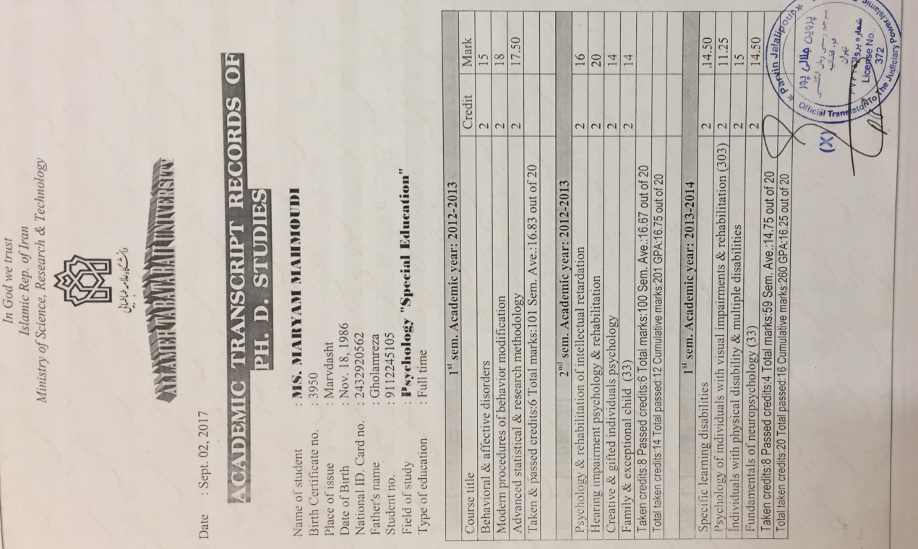

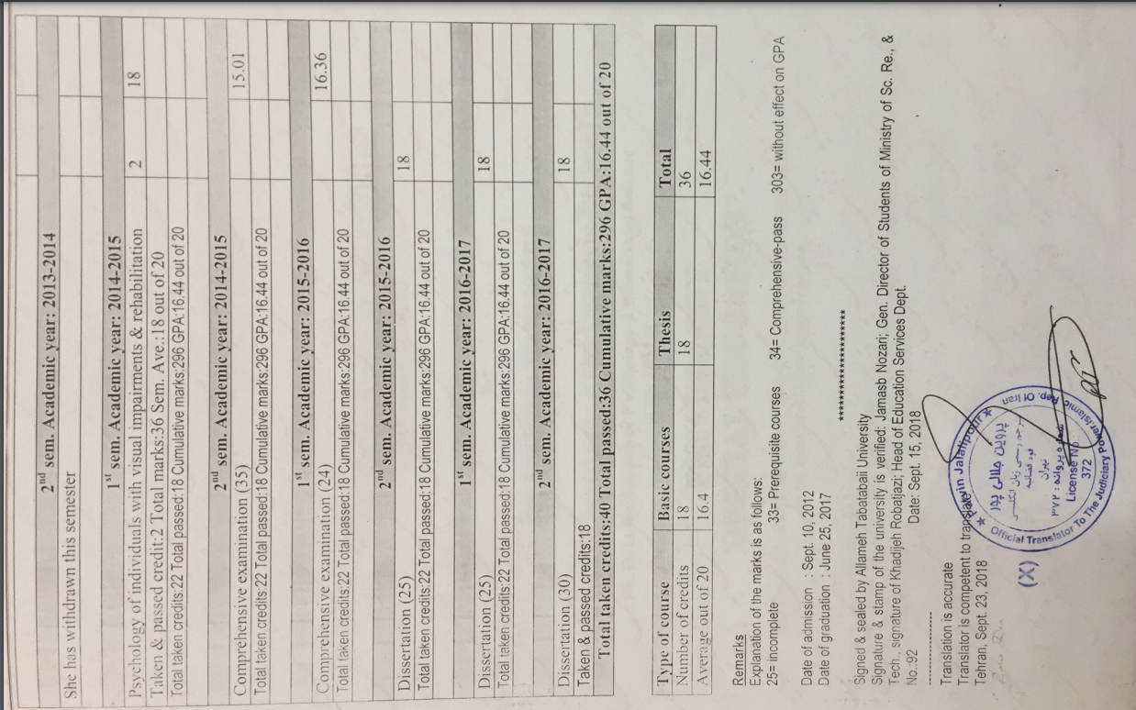

*Letter of endorsement from proposed mentor(s)*



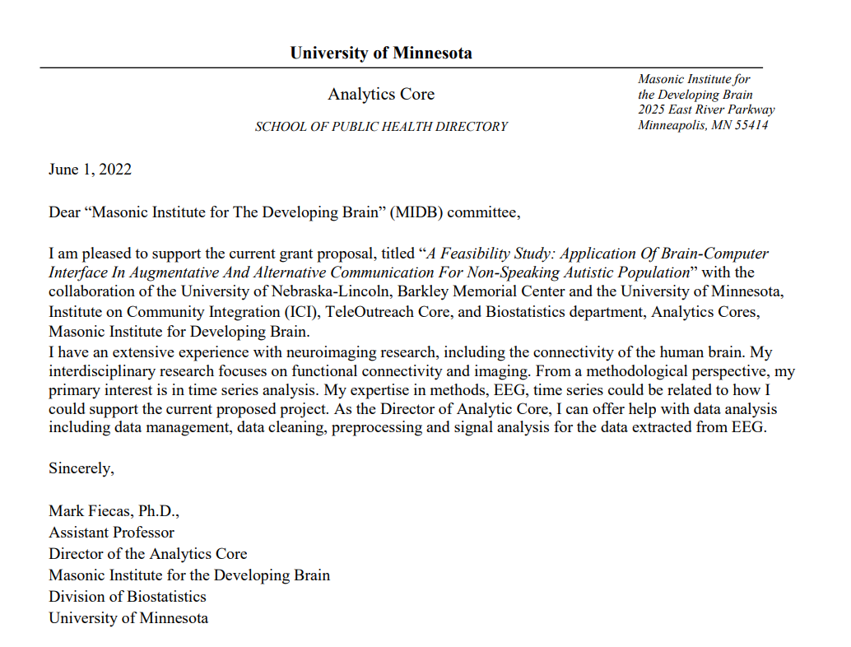

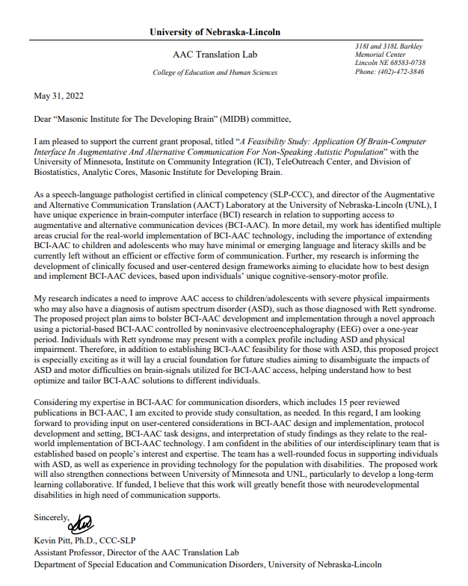

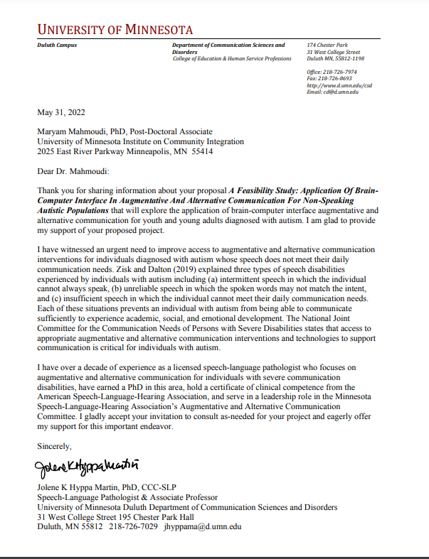

*Detailed budget and budget justification with timeline*



**Budget and Budget Justification [next page]**









*Please include information regarding the project’s IRB/IACUC status.*

The IRB application for the proposed project will be started once the proposal is granted.

**References**

1. *Diagnostic and statistical manual of mental disorders: DSM-5TM, 5th ed*. xliv, 947 (American Psychiatric Publishing, Inc., 2013). doi:10.1176/appi.books.9780890425596.

2. Baghdadli, A. *et al.* Adaptive trajectories and early risk factors in the autism spectrum: A 15-year prospective study. *Autism Res.* **11**, 1455–1467 (2018).

3. Rose, V., Trembath, D., Keen, D. & Paynter, J. The proportion of minimally verbal children with autism spectrum disorder in a community-based early intervention programme. *J. Intellect. Disabil. Res. JIDR* **60**, 464–477 (2016).

4. Wodka, E. L., Mathy, P. & Kalb, L. Predictors of Phrase and Fluent Speech in Children With Autism and Severe Language Delay. *Pediatrics* **131**, e1128–e1134 (2013).

5. Grodin, E. & McDonough, Y. Z. Autism and Her Writing: ‘Non-speaking doesn’t mean non-thinking’. *Lilith* vol. 46 7 (2021).

6. Convention on the Rights of Persons with Disabilities. *OHCHR* https://www.ohchr.org/en/instruments-mechanisms/instruments/convention-rights-persons-disabilities.

7. Mitchell, P., Sheppard, E. & Cassidy, S. Autism and the double empathy problem: Implications for development and mental health. *Br. J. Dev. Psychol.* **39**, 1–18 (2021).

8. Richards, C., Oliver, C., Nelson, L. & Moss, J. Self-injurious behaviour in individuals with autism spectrum disorder and intellectual disability. *J. Intellect. Disabil. Res. JIDR* **56**, 476–489 (2012).

9. Summers, J. *et al.* Self-Injury in Autism Spectrum Disorder and Intellectual Disability: Exploring the Role of Reactivity to Pain and Sensory Input. *Brain Sci.* **7**, 140 (2017).

10. McClelland, A. & Clark, E. Comparisons of Pivotal Response Treatment ( PRT ) and Discrete Trial Training ( DTT ). https://www.semanticscholar.org/paper/Comparisons-of-Pivotal-Response-Treatment-(-PRT-)-(-McClelland-Clark/dfea25edb3457e3a31d67750917ae69948afb6b4 (2016).

11. Paul, R. Interventions to Improve Communication. *Child Adolesc. Psychiatr. Clin. N. Am.* **17**, 835–x (2008).

12. Koegel, L. K., Bryan, K. M., Su, P. L., Vaidya, M. & Camarata, S. Definitions of Nonverbal and Minimally Verbal in Research for Autism: A Systematic Review of the Literature. *J. Autism Dev. Disord.* **50**, 2957–2972 (2020).

13. Rutter, M., Greenfeld, D. & Lockyer, L. A Five to Fifteen Year Follow-Up Study of Infantile Psychosis: II. Social and Behavioural Outcome. *Br. J. Psychiatry* **113**, 1183–1199 (1967).

14. Pickles, A., Anderson, D. K. & Lord, C. Heterogeneity and plasticity in the development of language: a 17-year follow-up of children referred early for possible autism. *J. Child Psychol. Psychiatry* **55**, 1354–1362 (2014).

15. DeMyer, M. K. *et al.* Prognosis in autism: A follow-up study. *J. Autism Child. Schizophr.* **3**, 199–246 (1973).

16. Holyfield, C. & Caron, J. Augmentative and Alternative Communication Technology Innovations to Build Skills and Compensate for Limitations in Adolescent Language. *Top. Lang. Disord.* **39**, 350–369 (2019).

17. Iacono, T., Trembath, D. & Erickson, S. The role of augmentative and alternative communication for children with autism: current status and future trends. *Neuropsychiatr. Dis. Treat.* **12**, 2349–2361 (2016).

18. Aydin, O. & Diken, I. H. Studies Comparing Augmentative and Alternative Communication Systems (AAC) Applications for Individuals with Autism Spectrum Disorder: A Systematic Review and Meta-Analysis. *Educ. Train. Autism Dev. Disabil.* **55**, 119–141 (2020).

19. Ganz, J. B. AAC Interventions for Individuals with Autism Spectrum Disorders: State of the Science and Future Research Directions. *Augment. Altern. Commun.* **31**, 203–214 (2015).

20. Lorah, E. R., Holyfield, C., Miller, J., Griffen, B. & Lindbloom, C. A Systematic Review of Research Comparing Mobile Technology Speech-Generating Devices to Other AAC Modes with Individuals with Autism Spectrum Disorder. *J. Dev. Phys. Disabil.* **34**, 187–210 (2022).

21. Holyfield, C., Drager, K. D. R., Kremkow, J. M. D. & Light, J. Systematic review of AAC intervention research for adolescents and adults with autism spectrum disorder. *Augment. Altern. Commun. Baltim. Md 1985* **33**, 201–212 (2017).

22. Ganz, J. B. *et al.* Interaction of Participant Characteristics and Type of AAC With Individuals With ASD: A Meta-Analysis. *Am. J. Intellect. Dev. Disabil.* **119**, 516–535 (2014).

23. Ganz, J. B. *et al.* An aggregate study of single-case research involving aided AAC: Participant characteristics of individuals with autism spectrum disorders. *Res. Autism Spectr. Disord.* **5**, 1500–1509 (2011).

24. Baxter, S., Enderby, P., Evans, P. & Judge, S. Interventions using high-technology communication devices: a state of the art review. *Folia Phoniatr. Logop. Off. Organ Int. Assoc. Logop. Phoniatr. IALP* **64**, 137–144 (2012).

25. Elsahar, Y., Hu, S., Bouazza-Marouf, K., Kerr, D. & Mansor, A. Augmentative and Alternative Communication (AAC) Advances: A Review of Configurations for Individuals with a Speech Disability. *Sensors* **19**, 1911 (2019).

26. Moorcroft, A., Scarinci, N. & Meyer, C. A systematic review of the barriers and facilitators to the provision and use of low-tech and unaided AAC systems for people with complex communication needs and their families. *Disabil. Rehabil. Assist. Technol.* **14**, 710–731 (2019).

27. Nam, S., Kim, J. & Sparks, S. An Overview of Review Studies on Effectiveness of Major AAC Systems for Individuals with Developmental Disabilities Including Autism. *J. Spec. Educ. Apprenticesh.* **7**, (2018).

28. Pitt, K. M., McKelvey, M. & Weissling, K. The perspectives of augmentative and alternative communication experts on the clinical integration of non-invasive brain-computer interfaces. *Brain-Comput. Interfaces* **0**, 1–18 (2022).

29. Vansteensel, M. J. & Jarosiewicz, B. Brain-computer interfaces for communication. *Handb. Clin. Neurol.* **168**, 67–85 (2020).

30. Simacek, J., Reichle, J. & McComas, J. J. Communication Intervention to Teach Requesting Through Aided AAC for Two Learners With Rett Syndrome. *J. Dev. Phys. Disabil.* **28**, 59–81 (2016).

31. Hossain, M. Y. & Doulah, A. B. M. S. U. Detection of Motor Imagery (MI) Event in Electroencephalogram (EEG) Signals using Artificial Intelligence Technique. in (2020).

32. Zander, T. O., Kothe, C., Jatzev, S. & Gaertner, M. Enhancing Human-Computer Interaction with Input from Active and Passive Brain-Computer Interfaces. in *Brain-Computer Interfaces: Applying our Minds to Human-Computer Interaction* (eds. Tan, D. S. & Nijholt, A.) 181–199 (Springer, 2010). doi:10.1007/978-1-84996-272-8_11.

33. M. G. Ezabadi & M. H. Moradi. A Novel Algorithm for Detection of Social Joint Attention from single-trial EEG signals of Autistic Spectrum Disorder (ASD). in *2021 28th National and 6th International Iranian Conference on Biomedical Engineering (ICBME)* 288–293 (2021).

34. Guger, C. *et al.* How Many People Could Use an SSVEP BCI? *Front. Neurosci.* **6**, (2012).

35. Dickinson, A., Gomez, R., Jones, M., Zemon, V. & Milne, E. Lateral inhibition in the autism spectrum: An SSVEP study of visual cortical lateral interactions. *Neuropsychologia* **111**, 369–376 (2018).

36. Cibrian, F. L., Mercado, J., Escobedo, L. & Tentori, M. A step towards identifying the sound preferences of children with autism. in (2018).

37. Niu, X. *et al.* *Invention and Application of Routine Treatment and New Intelligent Treatment Technology in Rehabilitation Training of Autistic Children*. vol. 799 (2022).

38. Sundaresan A *et al.* Evaluating deep learning EEG-based mental stress classification in adolescents with autism for breathing entrainment BCI. *Brain Inform.* **8**, 13 (2021).

39. Penchina, B., Sundaresan, A., Cheong, S. & Martel, A. *Deep LSTM Recurrent Neural Network for Anxiety Classification from EEG in Adolescents with Autism*. vol. 12241 (2020).

40. Eldeeb, S. *et al.* Trial by trial EEG based BCI for distress versus non distress classification in individuals with ASD. *Sci. Rep.* **11**, (2021).

41. Fan, J., Wade, J. W., Key, A. P., Warren, Z. E. & Sarkar, N. EEG-Based Affect and Workload Recognition in a Virtual Driving Environment for ASD Intervention. *IEEE Trans. Biomed. Eng.* **65**, 43–51 (2018).

42. Val-Calvo, M. *et al.* *Exploring the physiological basis of emotional HRI using a BCI interface*. vol. 10337 (2017).

43. Ravindranathan, R., Tommy, R. & Athira Krishnan, R. Experimental VALidation of findings using BCI in Autistic kids- (EVAL BCI). in vol. 2020 658–661 (2020).

44. Mercado, J., Escobedo, L. & Tentori, M. A BCI video game using neurofeedback improves the attention of children with autism. *J. Multimodal User Interfaces* **15**, 273–281 (2021).

45. Teo, S.-H. J. *et al.* Brain-computer interface based attention and social cognition training programme for children with ASD and co-occurring ADHD: A feasibility trial. *Res. Autism Spectr. Disord.* **89**, (2021).

46. de Arancibia, L., Sánchez-González, P., Gómez, E. J., Hernando, M. E. & Oropesa, I. Linear vs Nonlinear Classification of Social Joint Attention in Autism Using VR P300-Based Brain Computer Interfaces. in vol. 76 1869–1874 (2020).

47. Amaral, C. P., Simões, M. A., Mouga, S., Andrade, J. & Castelo-Branco, M. A novel Brain Computer Interface for classification of social joint attention in autism and comparison of 3 experimental setups: A feasibility study. *J. Neurosci. Methods* **290**, 105–115 (2017).

48. Bittencourt-Villalpando, M. & Maurits, N. Linear SVM Algorithm Optimization for an EEG-Based Brain-Computer Interface Used by High Functioning Autism Spectrum Disorder Participants. in vol. 76 1875–1884 (2020).

49. Castelo-Branco, M. *An Interventional Study to Improve Social Attention in Autistic Spectrum Disorder (ASD): A Brain Computer Interface (BCI) Approach*. https://clinicaltrials.gov/ct2/show/study/NCT02445625 (2019).

50. Simoes, M. *et al.* BCIAUT-P300: A Multi-Session and Multi-Subject Benchmark Dataset on Autism for P300-Based Brain-Computer-Interfaces. *Front. Neurosci.* **14**, 568104 (2020).

51. White, S. W. *et al.* Psychosocial and Computer-Assisted Intervention for College Students with Autism Spectrum Disorder: Preliminary Support for Feasibility. *Educ. Train. Autism Dev. Disabil.* **51**, 307–317 (2016).

52. Williams, R. M. & Gilbert, J. E. Perseverations of the academy: A survey of wearable technologies applied to autism intervention. *Int. J. Hum. Comput. Stud.* **143**, (2020).

53. J. van Kokswijk & M. Van Hulle. Self adaptive BCI as service-oriented information system for patients with communication disabilities. in *4th International Conference on New Trends in Information Science and Service Science* 264–269 (2010).

54. Khachatryan, E., Van Hulle, M. & Manvelyan, H. Cognitive evoked potentials: A method for investigation of language processing in brain. *New Armen. Med. J.* **9**, 32–37 (2015).

55. Khachatryan, E. *et al.* Language processing in bilingual aphasia: a new insight into the problem. *WIREs Cogn. Sci.* **7**, 180–196 (2016).

56. Khachatryan, E., Wittevrongel, B., De Keyser, K., De Letter, M. & Hulle, M. M. V. Event Related Potential Study of Language Interaction in Bilingual Aphasia Patients. *Front. Hum. Neurosci.* **12**, (2018).

57. Mora-Cortes, A., Manyakov, N. V., Chumerin, N. & Van Hulle, M. M. Language Model Applications to Spelling with Brain-Computer Interfaces. *Sensors* **14**, 5967–5993 (2014).

58. Pitt, K. M., Brumberg, J. S. & Pitt, A. R. Considering Augmentative and Alternative Communication Research for Brain-Computer Interface Practice. *Assist. Technol. Outcomes Benefits* **13**, 1–20 (2019).

59. Wittevrongel, B. *et al.* Towards asynchronous speech decoding. *Front. Neurosci.* **12**, (2018).

60. Shah, M. Peabody Picture Vocabulary Test, Fifth Edition (PPVT-5) – Forms A & B | Psychology Resource Centre. https://psycentre.apps01.yorku.ca/wp/peabody-picture-vocabulary-test-fifth-edition-ppvt-5-forms-a-b/.

61. Peabody Picture Vocabulary Test | Fifth Edition. https://www.pearsonassessments.com/store/usassessments/en/Store/Professional-Assessments/Academic-Learning/Brief/Peabody-Picture-Vocabulary-Test-%7C-Fifth-Edition/p/100001984.html.

62. Social Communication Questionnaire (SCQ) | Center for Autism Research. https://www.carautismroadmap.org/social-communication-questionnaire-scq/.

63. Lombardino, L. J. *et al.* The Early Reading Screening Instrument: a method for identifying kindergarteners at risk for learning to read. *Int. J. Lang. Commun. Disord.* **34**, 135–150 (1999).